Characteristics of Gaze Information according to Player's Experience under Searching Spaces of FPS Games

GyuHyeok Choi, Mijin Kim

Department of Visual Contents, Division of Digital Contents
Graduate School of Dongseo University, Dongseo University
Busan, South Korea
choi8603@hanmail.net, mjkim@dongseo.ac.kr

Abstract

In order for a player to achieve a game level goal, it is necessary to explore the space designed to provide a specific experience. Especially, in the FPS game, the space exploration of the player continuously occurs as a process of acquiring gaze information. In this paper, the player's spatial search condition in an FPS game was set and the player's gaze information was collected and analyzed through repetitive experiments. The results of the analysis would be used to confirm the association between the spatial search condition and the gaze information, and can be helpful in suggesting a method for setting a specific space at the game level.

Keywords-Searching Space; Gaze Information; FPS Gameplay;

I. Introduction

The space of the FPS game induces a situation that provides various experiences to achieve the game-level specific goal. These play experiences can be obtained by players performing events or quests placed throughout the play space. Such events and quests are called Beats, and in FPS games, Traverse, Using Object, and Be Attacked are used representatively [1]. Level designers set Beats at the game level design stage to provide players with a variety of experiences based on the unique purpose of space. Therefore, the configuration of Beats plays an important role in balancing the game level and establishing the organic relationship between the spatial elements. The FPS game player takes various game play actions as shown in Table 1 in the process of accomplishing Beats.
As shown in Table 1, each Beat induces different actions. Among them, Traverse Actions are the process of acquiring essential information for FPS game play and are the most basic action.
In an FPS game, the player's searching space action involves the acquisition of constant gaze information until a game-level goal is achieved. Therefore, analyzing the player's gaze information in the situation of searching space will enable derivation of necessary considerations in the process of setting the overall structure of the game level.

II. Searching Space and Gaze Information

A. Searching Space

Space refers to a specific area that consists of floor, ceiling, roof, and wall to draw a physical boundary line. It is structured depending on peripheral environment or may include an unstructured background. Users that experience space by small unit structure bestows a certain objective into a wide area through multiple uses of space unit. Interacting with small space (unit structure) sequentially, the user acts to the objective. According to these characteristics the space of the FPS game is not a simple background, but an interactive place where players' actions and reactions occur. In particular, since an FPS game is composed of an organic play space and it is played based on the player’s immediate action due to the genre characteristics, the space utilization is high [2]. Therefore, the player character continuously searches the play space to collect necessary information.
In fact, the importance of real searching space action can be known by comparing gameplay behavior time. For this, a pilot test was carried out in this research to analyze log data and the play behavior time taken by a player. Table 2 shows ten players’ playing actions by Beat carried out time while playing the game level (de_dust2) of an FPS game (Counter- Strike:Source) 10 times.
TABLE Ⅱ
PLAYTIME OF BEATS IN FPS GAME

Beats | Average time(s) | Ratio(%)
Traverse | 20.25 | 41.03
Using Object | 9.84 | 19.94
Be Attacked | 19.26 | 39.03
Total Playtime | 49.35 | 100

As shown in Table 2, Traverse actions are the highest rate of playtime (41.03%). Next, Be Attacked actions take up a high rate because FPS games have a battle-oriented gameplay structure where a player competes with the opponent through projectiles. Nonetheless, the proportion of Traverse actions in total playtime suggests the importance of spatial search action in FPS games. Previous studies on game player’s behavior analyzed the collected data quantitively by concentrating on the usage of space by a player or mainly focused on their behavioral process [3, 4, 5]. Because those attempts had the purpose of detecting the behavioral outcomes of game players, the conditions and circumstances of searching space, which is equal to the acquisition of prior information, by a game player were not considered in analysis. Therefore, it is necessary to conduct various and in-depth researches on searching space in gameplay.
TABLE I
GAMEPLAY ACTION IN BEATS

Beats | Gameplay Action
Traverse | Item search, enemy search, mission location search, object search, safety zone search
Using Object | Use of ladder, use of stairs, use of elevator, use of vehicle, use of turret
Be Attacked | Attack, changing weapon, reload, throw, installing explosion

Searching space is mainly based on reference to the player's previous experience or information acquired in real time during game play. This space information is collected from the instant gaze information of a player. In the current field of gameplay behavior research, it is used as analytic data to understand the structure and composition of game level. In addition, it is used as a way to increase the characteristics of a game by analyzing visual recognition points [6, 7].

B. Gaze Information

In FPS game, player’s gazing is used as a method to collect the data on visual recognition, and this specific field of online game is highly acknowledged as fit to gameplay behavior research because of the characteristics of its game genre that emphasizes reaction. As seen in Figure 1, gaze information-based gameplay analysis method can be applied to FPS game balancing [8].
One example for Figure 1 is that the spots where the gaze information of players are not acquired can be identified using ‘Eye gaze pattern’ and ‘Heat map’ simultaneously and analyzing the acquired data, and it helps the players through modifying light source in a game level. Therefore, this kind of analysis method has been studied as a new approach to evaluating and improving the complex structure of game levels. More in detail, studies are being conducted upon information of a player’s eye gaze in a combat situation, which is the main fun element of FPS game [8, 9]. In-depth research of eye gaze information helps plan a systematic placement of all the components of a game level. However, because the previous studies regarding gameplay behavior were limited to gaze information at combat situations, it cannot generalize the overall situations of a gameplay. Therefore, it is necessary to acquire and research gaze information at the situations of gameplay other than at a combat.
In this paper, gaze information at the situation of searching space was researched. The significance of this research lies in the fact that it helps examine the distinctions in the process of collecting the information of game players upon the elements placed at game level. This approach has the same objective as arranging an object (space or an item for a certain purpose) by analyzing the accessibility between spaces numerically based on the results of analysis only on space in the field of Space Syntax [5]. Eventually, it is expected that this method using gaze information can help place objects better in game levels.

III. Experiment

A. Purpose

The experiment was conducted to analyze the player's gaze movement required to acquire information in the situation of searching space, which is essential to achieve the game level goal.
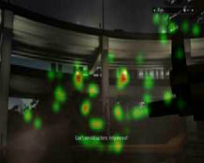
(1)Hard for a player to find the sniper’s position
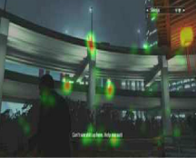
(2) Can find the sniper quickly
Fig. 1 The Case Applied with Eye Tracking in FPS Game

B. Material & Method

With the log data obtained in the pilot test carried out in advance, 3 items (Trigger, Weapon Fired, and Player Killed Other Weapon) were observed to be apparently different by the experience level of gameplay and the 10 participants were divided into 2 groups (5 Novices and 5 experts). And then a main test was given to 10 participants using the method of data measurement as seen in Table 3.
TABLE Ⅲ
EXPERIMENTAL CONDITIONS

Condition | Contents
When |  | 2017.06.26 ~ 06.30
Where |  | GES Lab at D Univ.
Who |  | Two professionals with knowledge of level design patterns and FPS game level analysis
How |  | Play testing based on references about the game level structure maps and level design patterns
 |  | Verify correspondence of the collected data separately by two professionals

As shown in Table 3, the game level selected as an experiment process was repeated to collected the visual data of 250 gaze information by group for 5 days (repeated 10 times a day). The image data of the players’ gaze was collected with an eye-tracking device. At this time, the specific game level (de_nuke) selected as experiment subject had a goal to explode a certain spot. The test point in Figure 2 was where gazing movement occurs most while doing ‘Traverse’ action: that is, the main focal point of pupils was more than 3 points.

C. Result

Gaze image information obtained in a combat situation was excluded from analysis because gaze concentration happens when an enemy character appears. The gaze image information of searching space situation was quite different by group (novice and expert).

As seen in Figure 3, the difference in gaze information between the two groups was confirmed. Th gaze of Novice Group in Figure 3-(1) was mainly directed toward the cross-hair located at the center of the screen or the tip of the player’s weapon. In addition, the collected information of their gaze was collected mostly on the structures setting up in the direction they wanted to travel. Besides, it was found that they hardly acquired information by changing gaze and normally gazed in the direction they were currently moving. In other words, their acquisition of gaze information concentrated on the center of the screen. This phenomenon occurs due to a lack of experience with FPS games. Game players have tendency of excluding the need to know information they do not known by depending on their own memories and experiences with a game. As a result, the concentration of gaze information on screen center occurs and this helps novices act quickly against an energy character appearing at the center of the screen. However, it has the demerit of slowing down the counteractions in case of engagement in a complex terrain or more than one passages, and the players end up under the attack of the enemy first.
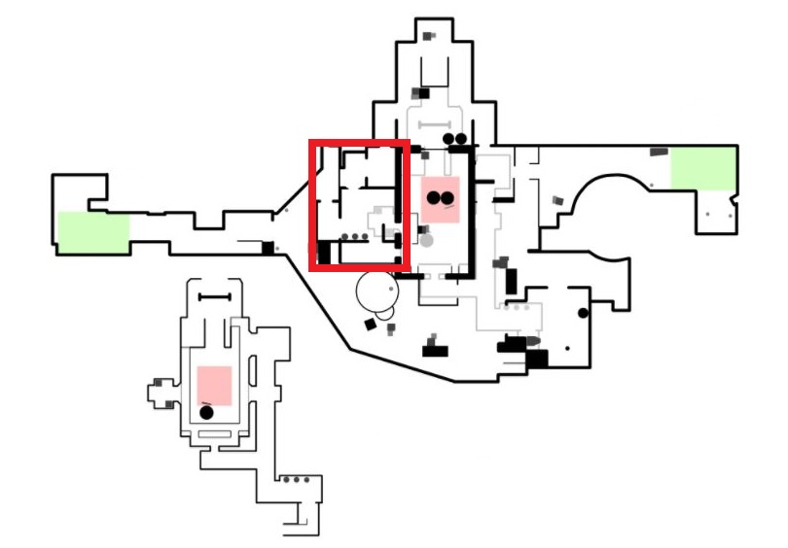
Fig. 2 Test Point in Game Level
On the other hand, Expert Group in Figure 3-(2) showed a distinction in its acquisition of gaze information from Novice Group. First of all, their gaze was on the cross-hair at the center of the game screen like seen in Novice Group. However, they tended to gaze around the spots where there was a chance the enemies might appear from their current position. It is the phenomenon that a player puts a problem solving on priority as well as tries to keep himself safe during playing a game. And their gaze aimed at a certain height through the cross hair, looking around in several directions at the same horizontal axis height as that of the cross hair. This means an action taken by a player that wants to turn a combat situation to his advantage by aiming at the height that he can give the most damage to his enemy in a short time according to his memories and experiences with a game. Recognizing the characteristics of terrain at the same height as the cross hair helps act (aim) quickly against an enemy when he (the enemy) appears in his sight. In addition, Expert Group showed the phenomenon of trying to grasp the topographic structures around them by gazing at Minimap that shows player’s position briefly. The minimap is a kind of simplified map that the game designer makes for a player’s convenience. It allows the player to easily point out his current location, the direction he looks in, the terrain structure around him, and the enemies within a certain range. Because of these merits, it was found that Expert group often used the minimap. It indicates that they try to scan space and make a direct confirmation with own gaze to increase the accuracy of information. As a result, they could easily cope with complicated terrain and various situations. However, there is a possibility that they play ‘Safety-oriented’ to achieve a goal, so it takes more playtime than needed.
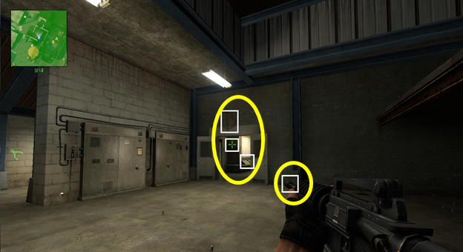
(1)Novice Group
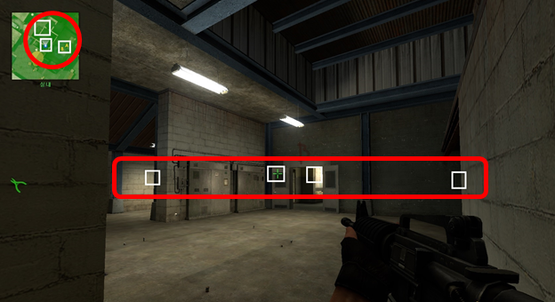
(2)Expert Group
Fig. 3 Features of Gaze Information
As a result, the two groups made respective distinctions in the acquisition of gaze information in situation of searching space, which resulted in the different characteristics of gameplay behavior. It is considered that the novice group focuses on acquiring the narrow information of space about the direction to move by focusing on the end point of the weapon and the objects in the center of the screen. On the other hand, the expert group can acquire a wide various information of space by considering the position of the current player and the predicted position of the enemy by frequently moving their gaze to the left and right while observing the mini map. The results of this analysis can provide important data in setting the structure of game level and arranging objects in it.

* In designing the game levels for novice players, it is advisable for a game level designer to simplify space in terms of its usage: he needs to reduce the passageways that turn at a right angle or multi-entrance buildings and use more straight passages so that enemy can appear in the direction a player travels. However, too much simplification can make players feel bored. Therefore, it is necessary to consider placing objects and covers in the passages.
* In designing the game levels for expert players, it is necessary for a game level designer to structure game space. It is better to make more locations where enemy can appear by placing more than 2 passageways and multiple objects, than multifunctional topographical structures. Here, caution is worth taking not to make expert players feel too familiar to space from their prior experiences. That is, the height at which enemy is expected to appear should vary so it can give the players a new and fresh experience.

IV. Conclusion

This paper identified the different characteristics in gaze information according to the player's experience level in the situation of searching space on FPS games. Based on the game play log data, 10 people were divided into novice and expert groups, 5 people each, and the real-time gaze information images were collected and analyzed using eye-tracking. In the situation of searching space, the two groups showed differences in the primary purpose of acquiring the gaze point and information of space. These analytical methods and results will be able to provide meaningful data for game level spatial structure and component placement.

References

[1] M. Davies, “Examining Game Pace: How Single-Player Levels Tick,” Gamasutra, May 2009.
[2] D. Clarke, P. R. Duimering, “How computer gamers experience the game situation: a behavioral study,” Computers in Entertainment (CIE), Vol. 4, Issue. 3, No. 6, 2006.
[3] Hullett, K., and Whitehead, J., Design Patterns in FPS Levels, In proceedings of the Fifth International Conference on the Foundations of Digital Games, ACM, New York: Press, June 2010, pp.78-85.
[4] Thurau, C., and Drachen, A., Player Behavior and Play Experience, Springer, (2013).
[5] Drachen, A., and Canossa, A., Analyzing spatial user behavior in computer games using geographic information systems, In Proceedings of the 13th International MindTrek Conference: Everyday Life in the Ubiquitous Era, ACM, September 2009, pp. 182-189.
[6] R. Bernhaupt, M. Eckschlager, and M. Tscheligi, "Methods for evaluating games: how to measure usability and user experience in games?," Proceedings of the international conference on Advances in computer entertainment technology, ACM, pp.309-310, Jun, 2007.
[7] R. Bernhaupt, W. Ijsselsteijn, F.F. Mueller, M. Tscheligi, and D. Wixon, "Evaluating user experiences in game," CHI'08 extended abstracts on Human factors in computing systems, ACM, pp.3905-3908, Apr 2008.
[8] S. A. Johansen, M. Noergaard, and J. Rau, "Can eye tracking boost usability evaluation of computer games." Proceedings of CHI, Vol. 8, 2008.
[9] G. Choi, M. Kim, “Analysis of Players’ Eye-Movement Patterns by Playing Experience in FPS Game,” Smart Media Journal, Vol. 5, No. 2, pp. 33-41, 2016.

